**AI COMPANION: Used by counselors, psychiatrist to track their patients mental health:**

**1.** Intelligent Mood Tracking & Sentiment Analysis

* Uses natural language processing (NLP) to analyze user inputs (texts, voice notes) and detect emotional states (e.g., stress, anxiety, sadness, positivity).
* Tracks mood trends over time and visualizes them (for both user and assigned counselor).
* Can prompt users with follow-up questions:  
   *“You sound a bit low today. Want to talk or take a quick grounding break?”*

 2. Daily Mental Health Check-ins

* Sends gentle check-in prompts tailored to emotional well-being:  
   *“Hey, how are you really doing today on a scale of 1–10?”*
* Offers options to log emotions (emoji slider, journal entry, or voice note).
* Recognizes concerning patterns (e.g., low mood streaks) and flags them for counselors.

 3. Counselor Dashboard Integration

* Provides summarized insights to mental health professionals:
  + Weekly mood graphs
  + Common emotional triggers
  + Highlighted journal entries or conversation snippets (with consent)
* Enables psychiatrists/therapists to make informed decisions during sessions.

4. Adaptive Coping Tools & Exercises

* Recommends personalized exercises based on emotional state:
  + Breathing or mindfulness exercises
  + Gratitude journaling prompts
  + Distraction videos or light-hearted content (memes, music)
* For example:  
   *“Feeling anxious? Here’s a 1-minute breathing tool to center yourself 🌿”*

 5. Personalized Goal Tracking

* Supports therapy/counseling goals (e.g., improving sleep, reducing social anxiety, journaling consistency).
* Nudges users gently toward achieving those goals, without pressure.
* Tracks habits and celebrates milestones:  
   *“3 days in a row of writing in your journal — that’s real progress 🎉”*

 6. Crisis Response & Safety Protocol

* Detects potential signs of crisis (e.g., self-harm language, depressive patterns).
* Immediately:
  + Suggests grounding exercises
  + Prompts contact with a trusted person
  + Alerts counselor (or triggers escalation protocols if integrated with an organization)
* Example:  
   *“It seems like you might be feeling overwhelmed. Do you want me to notify your counselor or connect you to a helpline?”*

 7. Data Privacy & Consent

* All data is encrypted and accessible only by the user and their assigned counselor.
* Consent-based data sharing: users decide what to share with their counselor.
* Regular reminders of privacy policy and control over stored interactions.

 8. Context-Aware Conversations

* Uses LLM capabilities to remember context and personalize replies over time:  
   *“Last week, you said crowded spaces made you anxious. Want to talk about how it went today?”*

 9. Weekly Therapist Collaboration Bundle

* Automatically generates:
  + Summary of week’s emotional highs/lows
  + Notable changes in patterns or mood
  + Suggested topics to bring up in the next session
* Sent directly to counselor or therapist dashboard.

 10. Engagement & Gentle Motivation

* Adds gamified elements (e.g., streaks, “leveling up” mental health habits) without pressure.
* Provides affirmations, mood boosters, and positive reinforcement.
* Example:  
   *“Today was tough, but you showed up. That’s strength. 💪 Want to log something you're proud of?”*

 Positioning Summary

Kai is no longer just a friendly motivator—it’s now a trusted, intelligent mental health companion that:

* Supports users emotionally and practically
* Provides counselors with actionable insights
* Maintains ethics, privacy, and empathy at its core

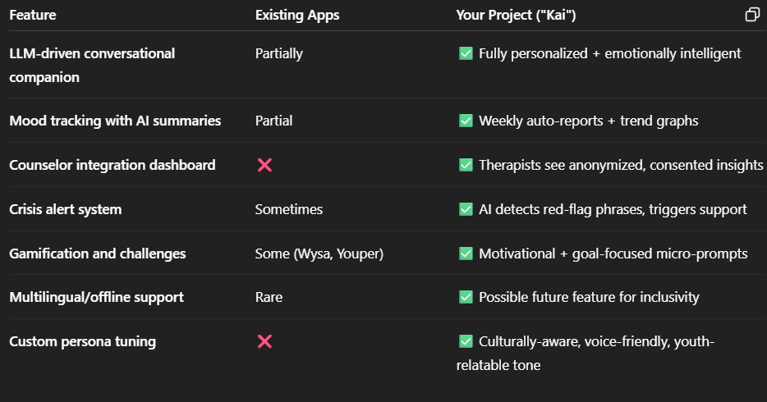

 MODULES OVERVIEW

1. User Authentication & Authorization

* Features:
  + Sign up / login for patients and counselors
  + Role-based access (admin, counselor, patient)
  + Two-factor authentication (optional)
* Tech: Firebase Auth, JWT, OAuth2

2. Patient Dashboard

* Features:
  + Daily mood check-in (text/emoji/voice/image)
  + AI companion chat interface (Kai)
  + Goal tracking & micro-challenges
  + Mental health journaling
* Tech: React/Vue (Frontend), Node/Flask/Firebase (Backend)

3. Counselor Dashboard

* Features:
  + Access to assigned patients' mental health summaries (with consent)
  + Weekly reports & trends
  + View flagged sessions (e.g., signs of distress)
  + Option to send nudges or resources to patients
* Tech: Web interface + charting libraries (Chart.js, Recharts)

4. AI Chatbot (Kai) Module

* Features:
  + LLM-powered chat with tone, personality, and emotional awareness
  + Context retention (short-term and long-term memory)
  + Dynamic goal setting, journaling prompts
  + Language customization & empathy detection
* Tech: OpenAI GPT-4 / Llama 3, LangChain, RAG (for personalized info)

5. Mood & Sentiment Analysis Engine

* Features:
  + Natural Language Processing on user text
  + Optional facial expression or voice emotion analysis
  + Mood trend visualization
* Tech: spaCy, HuggingFace Transformers, Google ML Kit, MediaPipe

6. Data Logging & Journaling System

* Features:
  + Secure storage of journal entries, mood logs, and goal progress
  + Option to export data (PDF/CSV) for therapy sessions
* Tech: MongoDB / Firebase / PostgreSQL

7. Alerts & Crisis Detection

* Features:
  + Real-time detection of distress or crisis language
  + Sends alerts to assigned counselor or emergency contact
  + Escalation logic (e.g., suicide risk, self-harm)
* Tech: Keyword-based + ML model for red-flag detection

8. Push Notifications & Reminders

* Features:
  + Daily nudges
  + Session reminders
  + Weekly progress notifications
* Tech: Firebase Cloud Messaging / OneSignal

9. Gamification & Engagement

* Features:
  + Challenges, badges, streaks, and points
  + Visualization of personal growth
* Tech: Local state management + user progress tracking

10. Settings & Customization

* Features:
  + Theme (light/dark)
  + Notification preferences
  + AI tone/persona tuning
  + Language settings
* Tech: User preference storage (cloud/local)

11. Admin Panel (Optional)

* Features:
  + Manage users, therapists, and flagged conversations
  + View anonymized usage statistics